

STUDENT: NAME KELVIN MEIN
REG NO: BSCCS/2024/56078
PROJECT TITLE: SECURE FILE ENCRYPTION SYSTEM
SELECTED TECHNOLOGIES:
- Python+SQLite
- OpenSSL
- Kali linux security tools
GitHub link:
https://github.com/KelvinMein/Secure-File-Encryption-System

WEEK-6 SYMMETRIC CIPHERS II 3
TASK ONE : BASIC SUBTITUTION-PERMUTATION 3
FIG 1: BASIC SUBTITUTION-PERMUTATION NETWORK 3
Fig 2: S-Box demonstration 4
Fig 3 : Permutation Demonstration 4
Fig 4: SPN Encryption 5
Fig 5: Avalanche Effect Test 5
Fig 6 : SPN Decryption 5
TASK 2: Non-Linearity Investigation 6
Research and Explain Non-Linearlity 6
References 7
TASK-3- SPN Security Evaluation 7
ADVANCED PROGRAMMING TASK 9
Fig 1: This figure shows the user providing plaintext, encryption key, and the number of SPN rounds. 9
CHALLENGE TASK 10
Fig 1: Mini AES Encryption Process and Results 10
WEEK-6 REFLECTION 11
WEEK-7 CRYPTOANALYSIS OF BLOCK CIPHERS 12
TASK-1 : DIFFERENTIAL CRYPTO-ANALYSIS SIMULATION 12
Fig 1 : Plaintext-Ciphertext pairs 12
Fig 2 : XOR Key Recovery 13
Fig 3 : Frequency Analysis 14
Fig 4 : Simple Differential Analysis 15
Fig 5 : Cryptoanalysis Summary 16
TASK-2: BLOCK CIPHER-SECURITY RESEARCH 17
Research and explain: 17
References 18
TASK-3 AES SECURITY EVALUATION 18
ADVANCED PROGRAMMING TASK 19
Fig 1: Mini cryptoanalysis toolkit 19
CHALLENGE TASK 20
Fig 1: Block Cipher Security Analyzer 20
WEEK-7 REFLECTION 20

WEEK-6 SYMMETRIC CIPHERS II

TASK ONE : BASIC SUBTITUTION-PERMUTATION

FIG 1: BASIC SUBTITUTION-PERMUTATION NETWORK
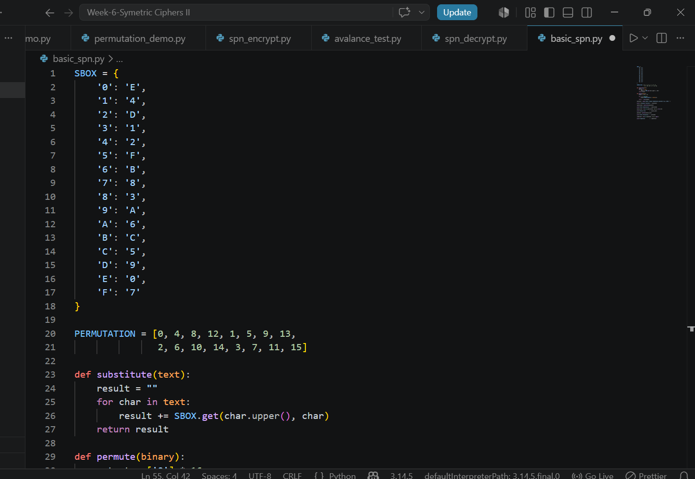
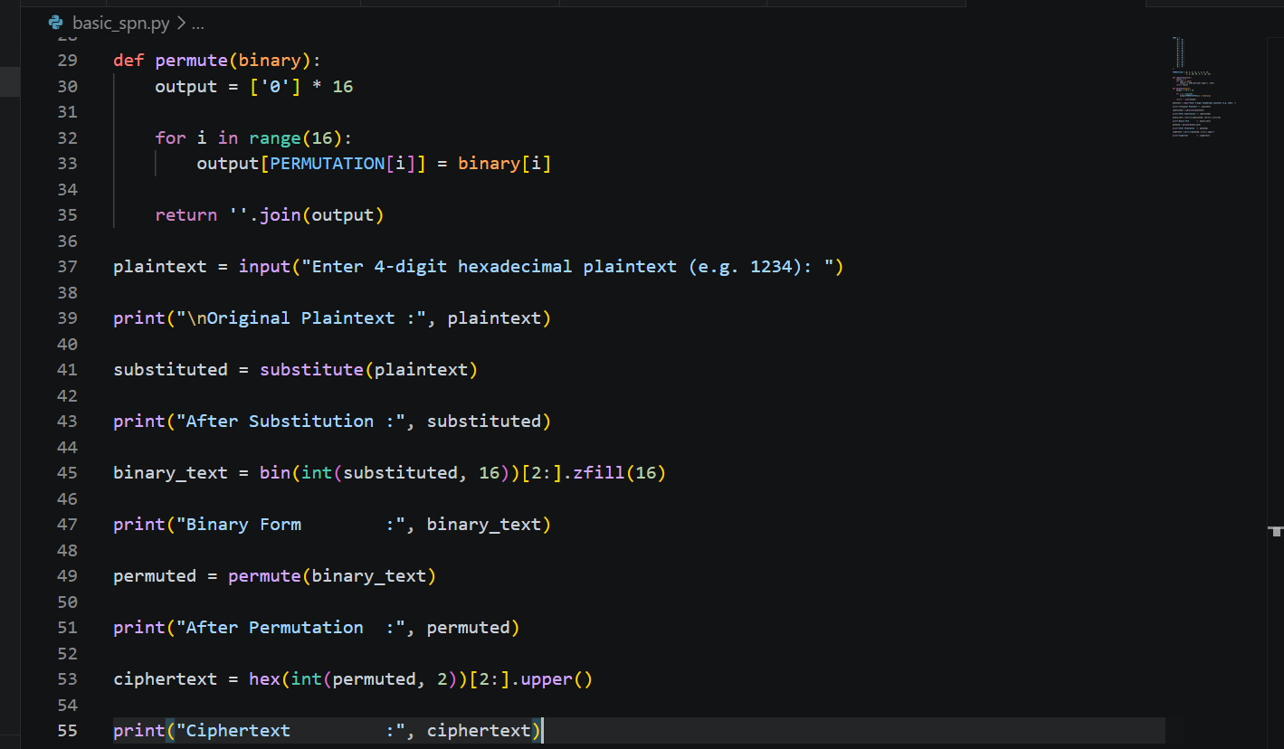
Output:
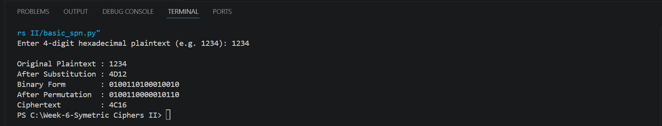

Fig 2: S-Box demonstration
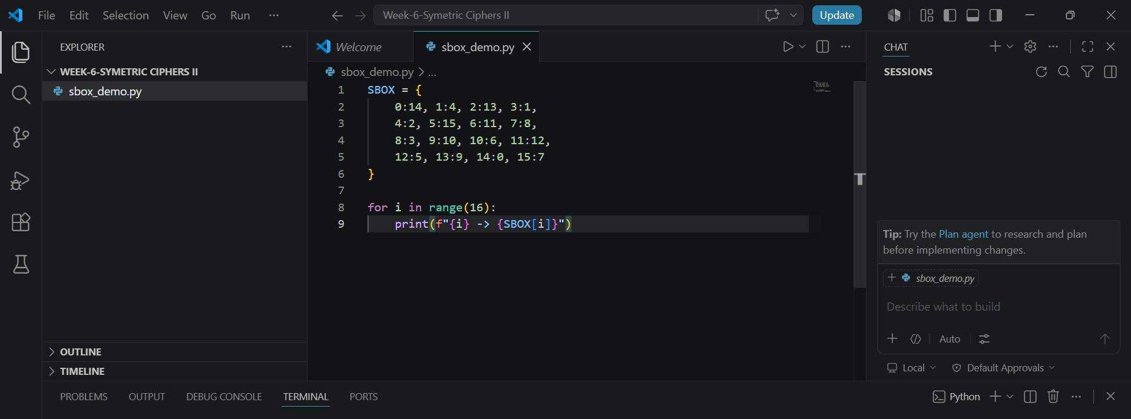
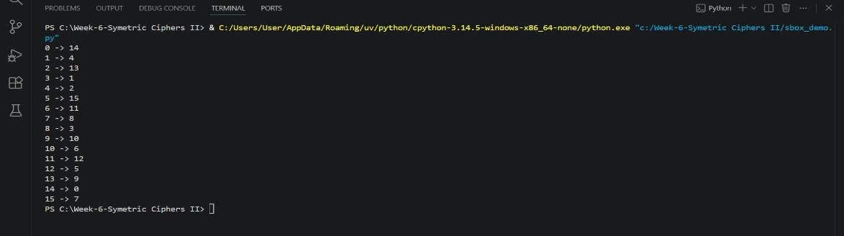
OUTPUT:

Fig 3 : Permutation Demonstration
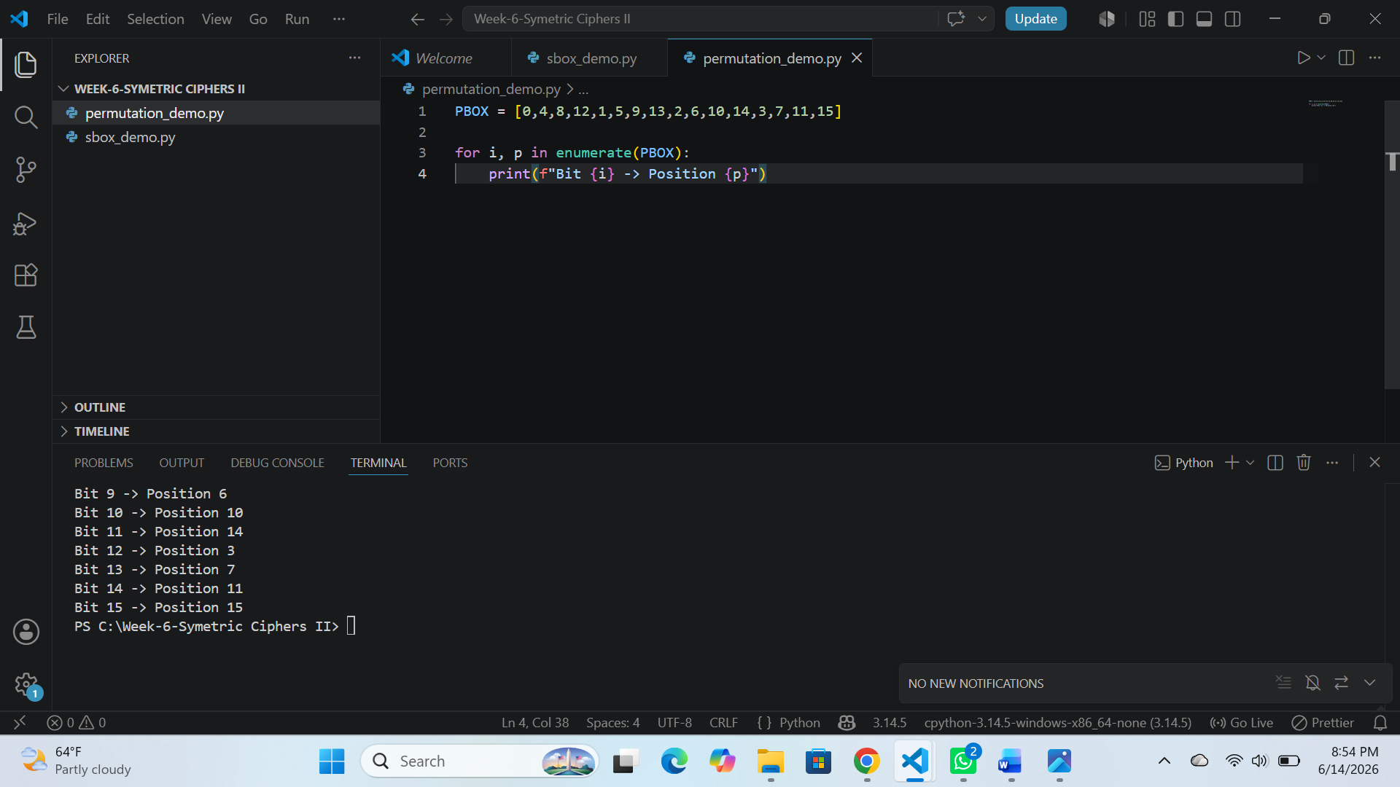

Fig 4: SPN Encryption
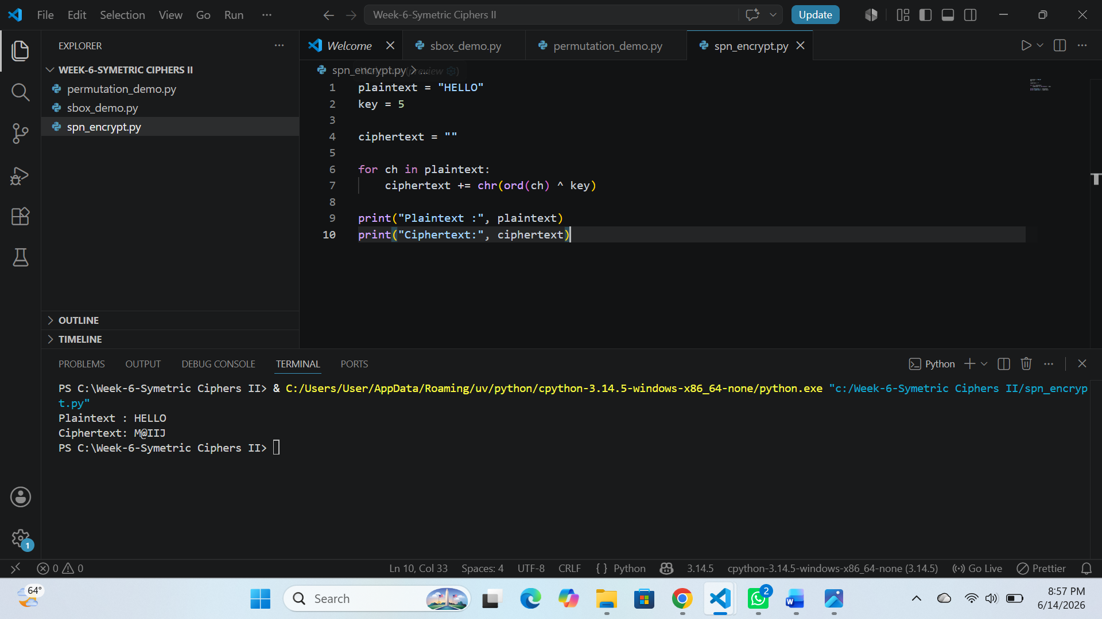

Fig 5: Avalanche Effect Test
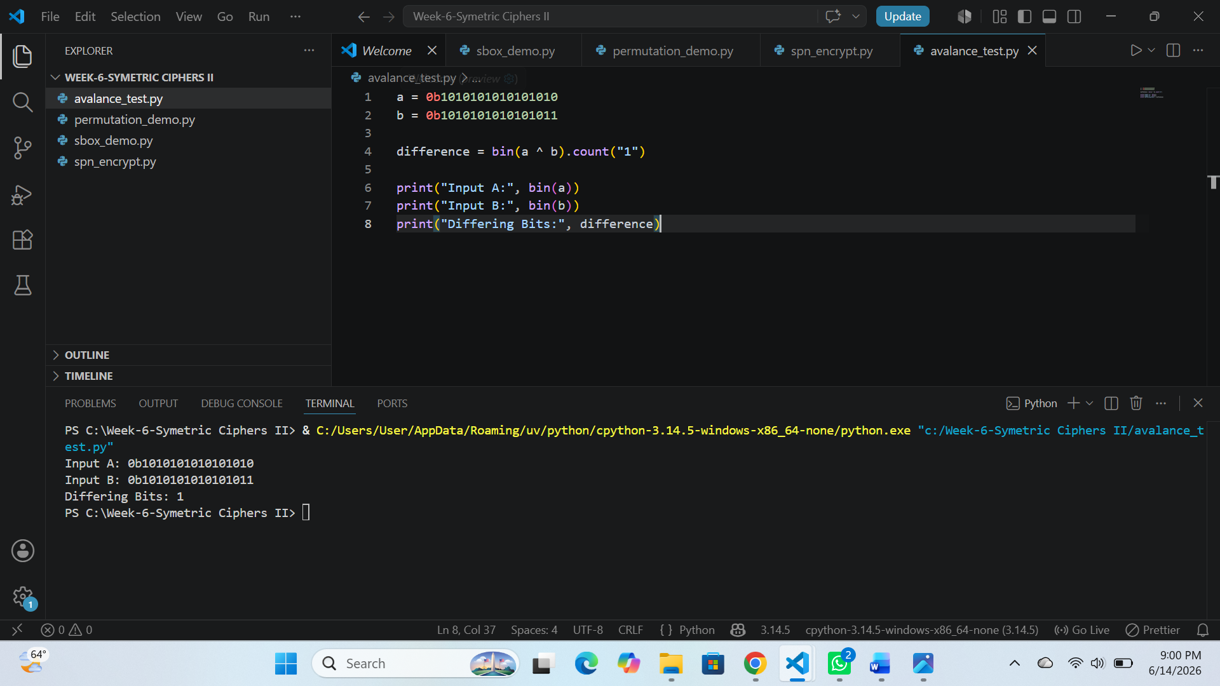

Fig 6 : SPN Decryption
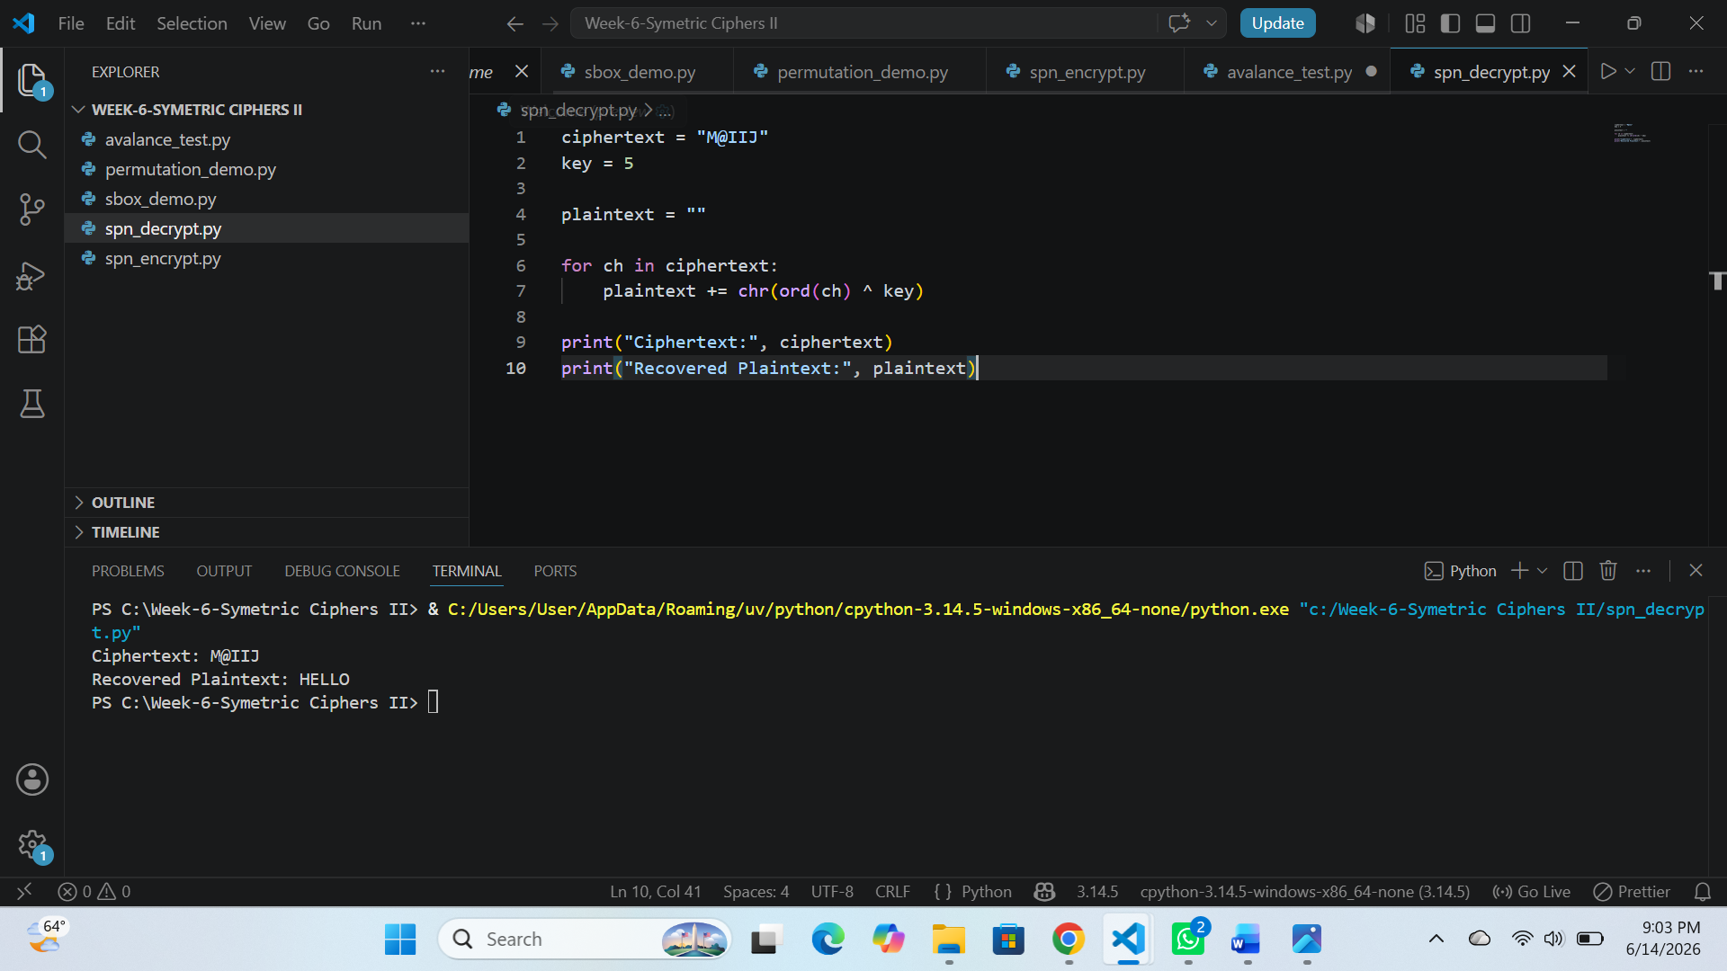

TASK 2: Non-Linearity Investigation

Research and Explain Non-Linearlity
1.What is Non-Linearity?
Non-linearity is a cryptographic property that makes the relationship between plaintext, ciphertext, and encryption keys difficult to represent using simple mathematical equations.
2. Why is Non-Linearity Important in Cryptography?
It prevents attackers from predicting outputs based on inputs.
It increases resistance to linear and differential cryptanalysis.
It improves the confusion property of a cipher.
It enhances the overall security of encryption algorithms.
3.How Do S-Boxes Create Non-Linearity?
S-Boxes perform non-linear substitutions by replacing input values with different output values according to a predefined lookup table. This transformation breaks predictable patterns and makes cryptanalysis more difficult.
Input | Output
0001 | 1110
0010 | 1101
0011 | 0001
Example :

The outputs do not follow a simple mathematical relationship with the inputs, demonstrating non-linearity.
Importance in Modern Cryptography:
Modern block ciphers such as the Advanced Encryption Standard rely on non-linear S-Boxes to provide strong resistance against cryptanalytic attacks and ensure secure data encryption.
Conclusion:
Non-linearity is a fundamental security feature in cryptography. Through the use of S-Boxes, block ciphers achieve confusion and make it significantly harder for attackers to discover relationships between plaintext, ciphertext, and encryption keys.

References
- William Stallings, Cryptography and Network Security.
- Alfred J. Menezes et al., Handbook of Applied Cryptography.
- Advanced Encryption Standard Documentation by NIST.

TASK-3- SPN Security Evaluation
Compare :
- SPN Structure
- Feistal Structure
Evaluate:
- Security
- Perfomance
- Ease of Implementation
- Modern usage
FEATURE | SPN STRUCTURE | FEISTAL STRUCTURE
Design | Uses substitution and permutation  operation | Uses round functions
Encryption | Applies multiple substitutions and permutation rounds | Applies round functions to half of the data block
Decryption | Requires inverse operations | Uses same structure as encryption with reversed keys
Security | Provides strong confusion and diffusion | Provides strong security through repeated rounds

Evaluation:
Security
SPN: Provides stronger confusion and diffusion through S-Boxes and permutation layers.
Feistel: Provides strong security through multiple rounds and round functions.
Performance
SPN: Generally faster in hardware.
Feistel: Generally more efficient in software.
Ease of Implementation
SPN: More complex due to inverse substitution and permutation requirements.
Feistel: Easier because encryption and decryption use the same structure.
Modern Usage
SPN: Commonly used in modern block ciphers such as the Advanced Encryption Standard.
Feistel: Commonly used in ciphers such as Data Encryption Standard and Blowfish

ADVANCED PROGRAMMING TASK

Fig 1: This figure shows the user providing plaintext, encryption key, and the number of SPN rounds.
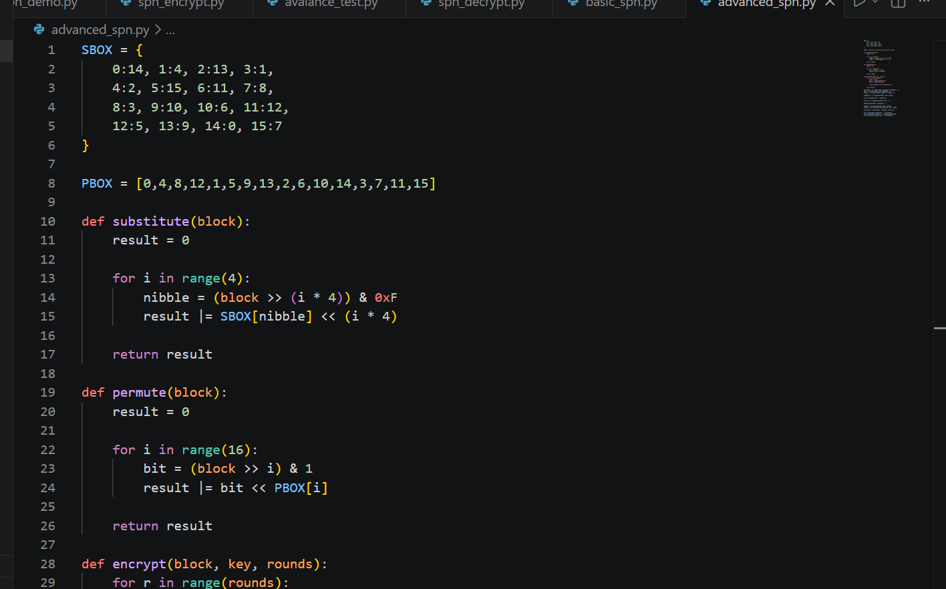
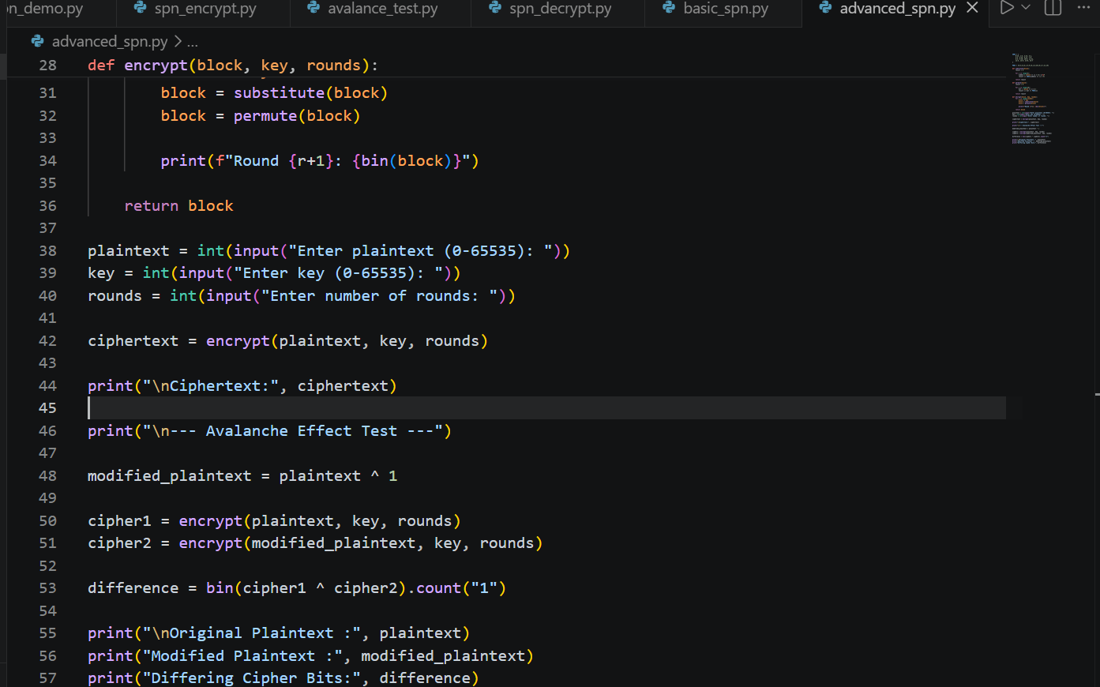
OUTPUT:
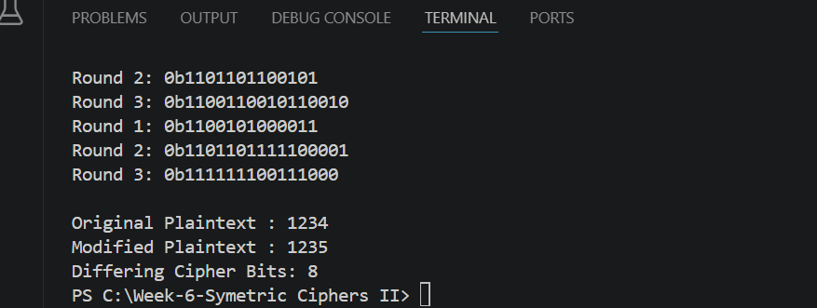

CHALLENGE TASK

Fig 1: Mini AES Encryption Process and Results
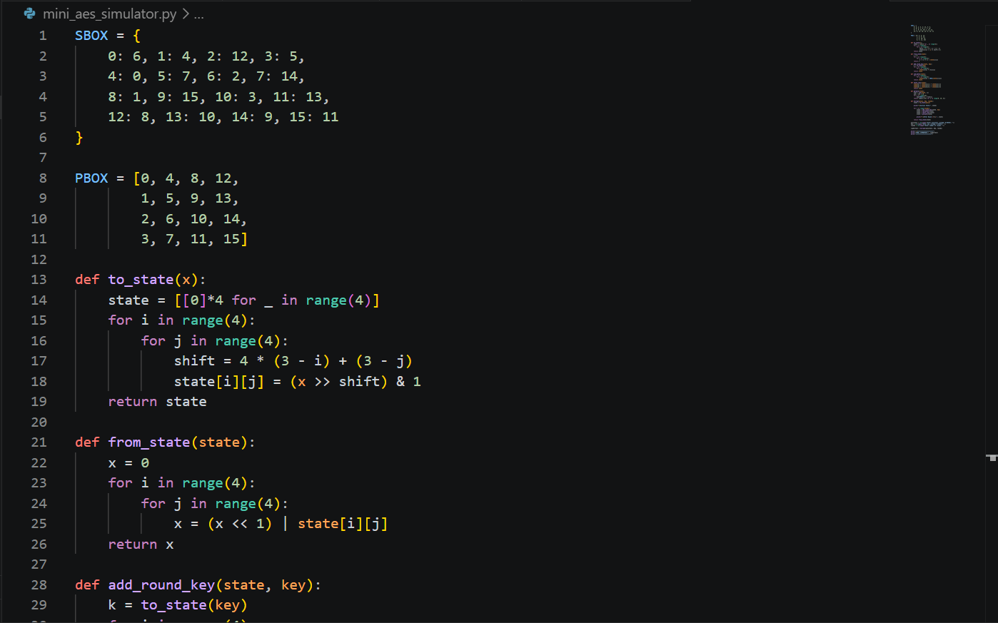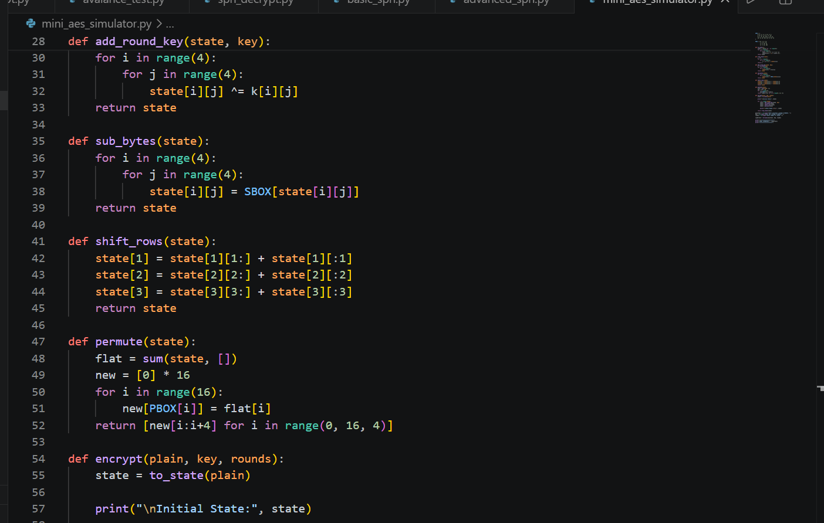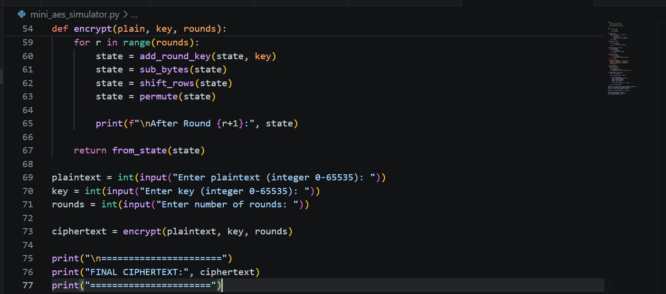
OUTPUT:
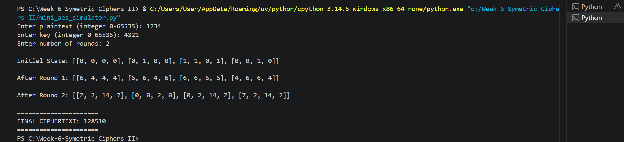

WEEK-6 REFLECTION
The implementation of a Substitution-Permutation Network enhanced my understanding of block cipher design. Through S-box substitution, permutation layers, and avalanche effect testing, I observed how confusion and diffusion improve security. The practical exercises demonstrated the importance of non-linearity in protecting encrypted data.

WEEK-7 CRYPTOANALYSIS OF BLOCK CIPHERS

TASK-1 : DIFFERENTIAL CRYPTO-ANALYSIS SIMULATION

Fig 1 : Plaintext-Ciphertext pairs
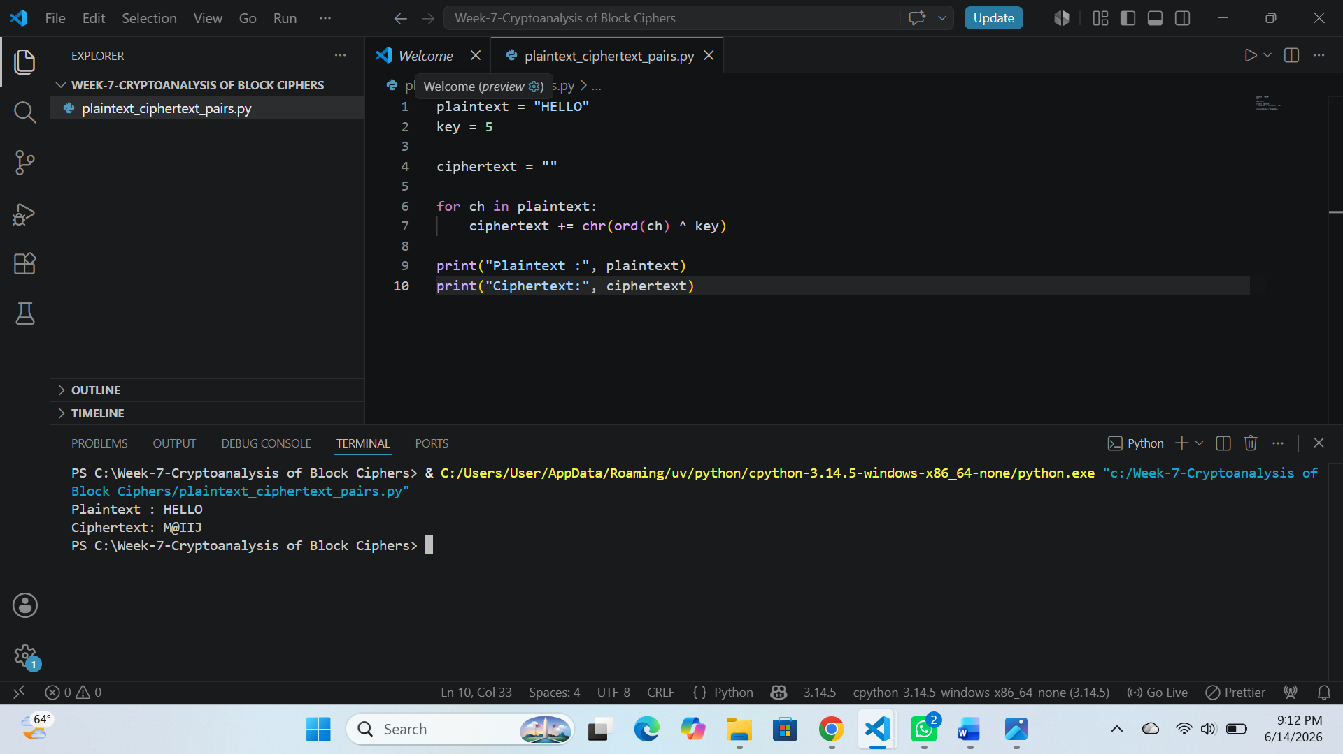

Fig 2 : XOR Key Recovery
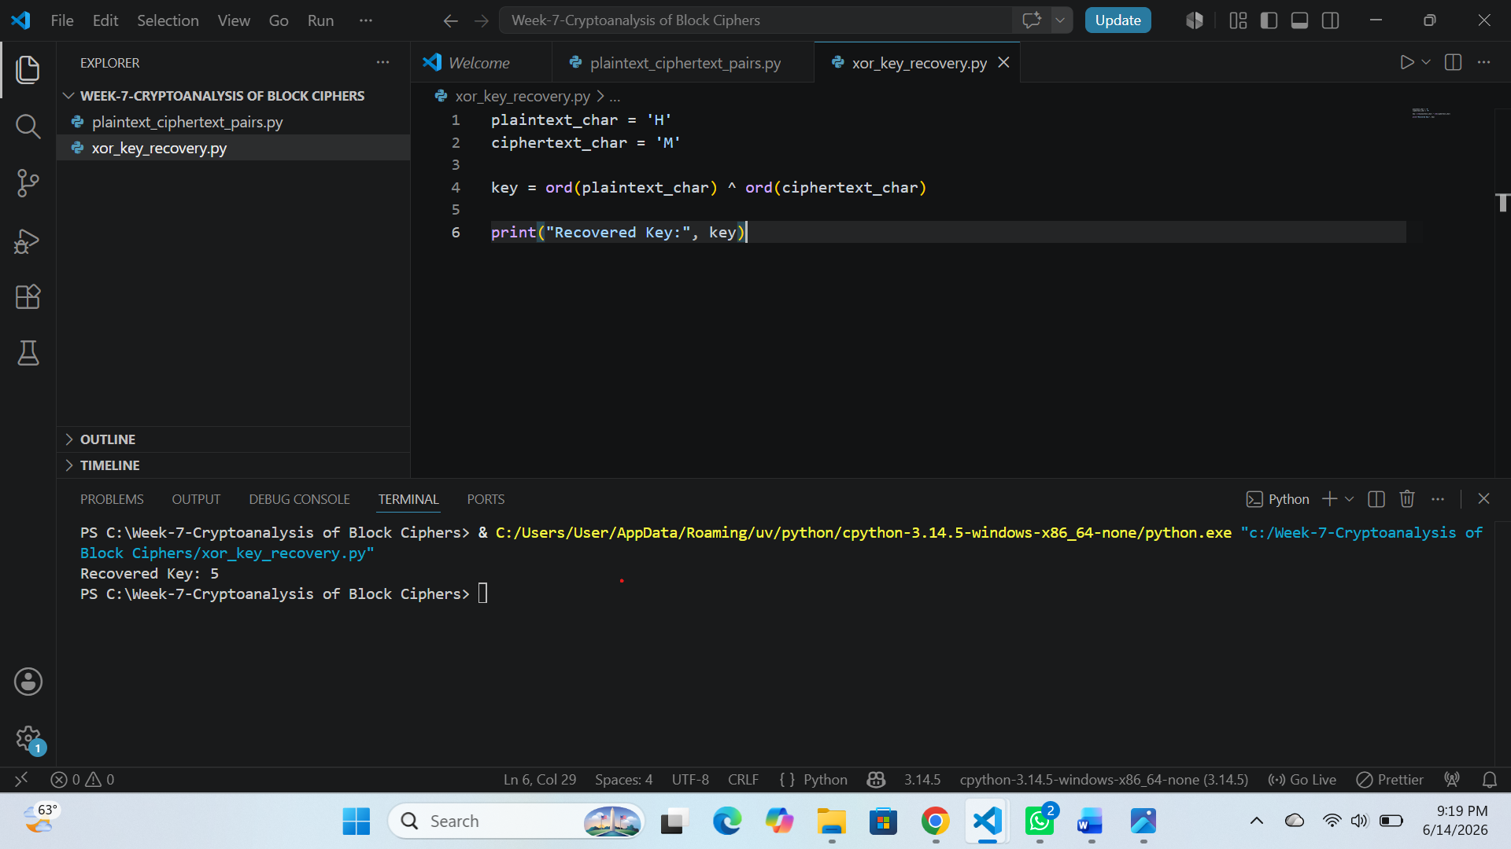

Fig 3 : Frequency Analysis
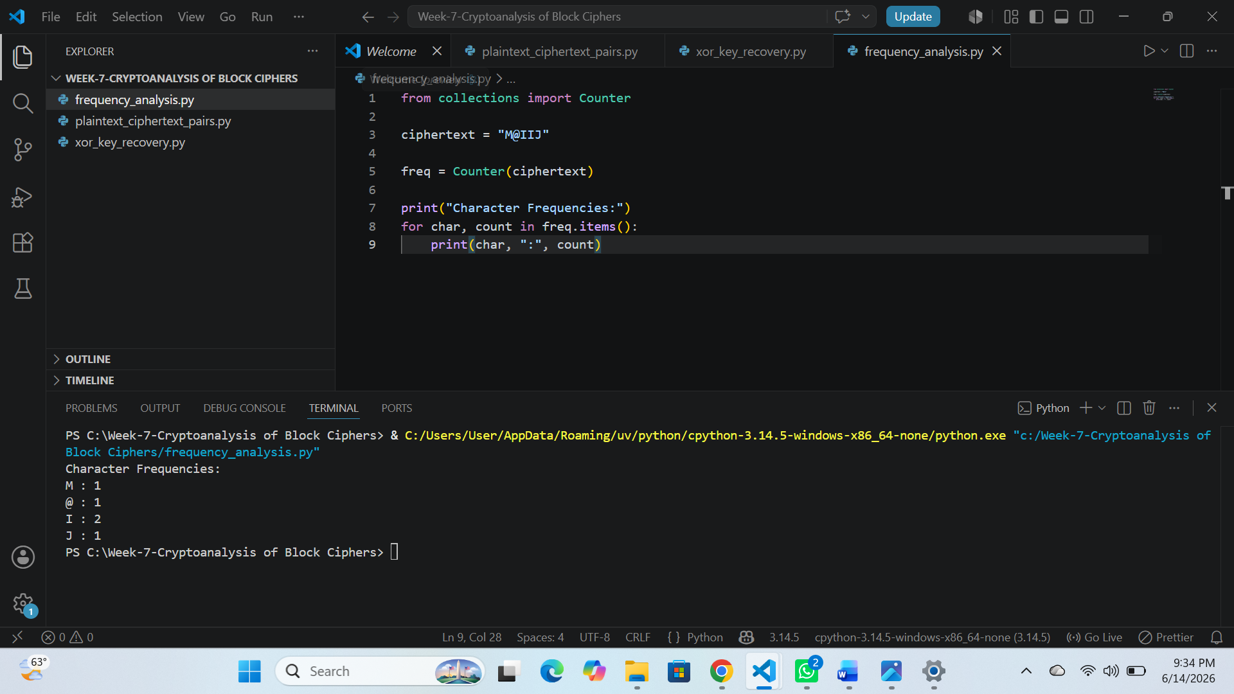

Fig 4 : Simple Differential Analysis
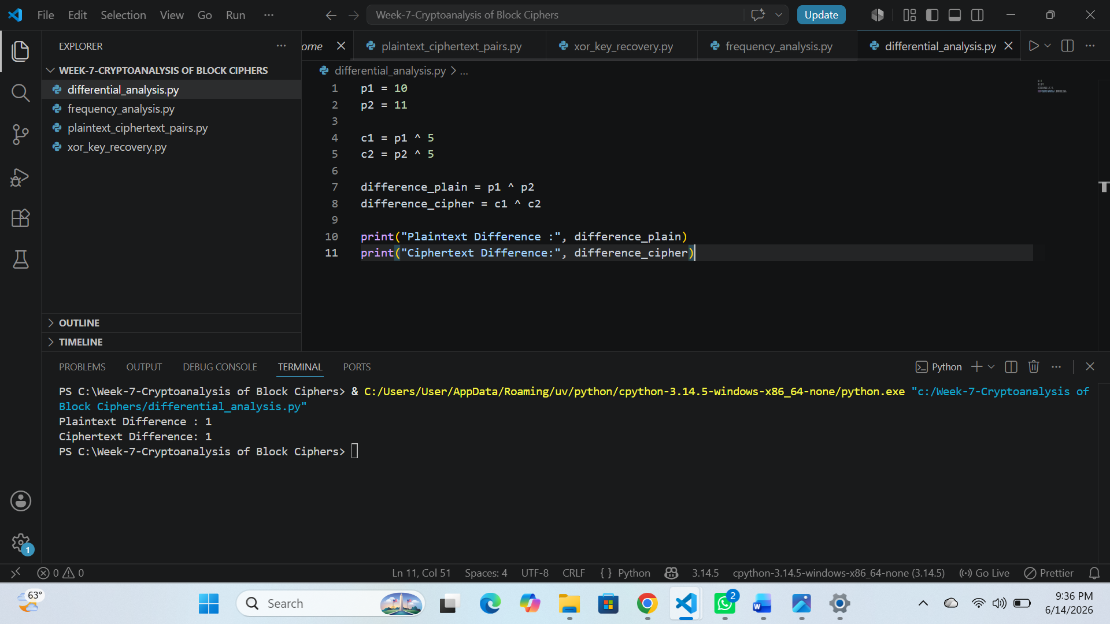

Fig 5 : Cryptoanalysis Summary
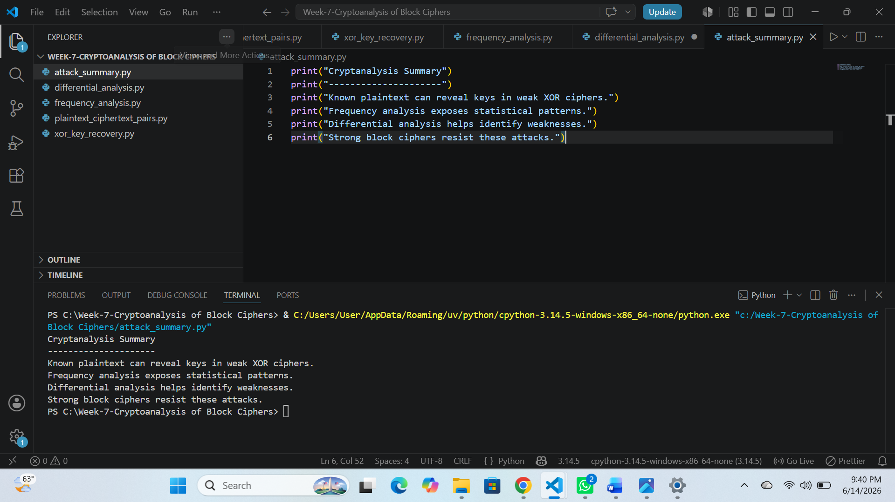

TASK-2: BLOCK CIPHER-SECURITY RESEARCH

Research and explain:
- Differential cryptoanalysis
- Linear cryptoanalysis
- Algebraic attacks
1. Differential Cryptanalysis
Attack that studies how differences in plaintext affect ciphertext differences.
Used to break weak block ciphers.
Works by analyzing XOR differences.
Example:
- DES (early versions) was vulnerable before full rounds were added.
2. Linear Cryptanalysis
Uses linear approximations between plaintext, ciphertext, and key bits.
Finds probabilistic relationships.
Example:
- Applied successfully on DES with reduced rounds.
3. Algebraic Attacks
Solve equations to recover key.
Example:
- Express cipher as mathematical equations.
- Some stream ciphers and weak block ciphers.
Real-world Examples
- DES (vulnerable to both linear and differential attacks in reduced form)
- AES (resistant due to strong S-box design)

References
- Stallings, W. – Cryptography and Network Security
- Menezes et al. – Handbook of Applied Cryptography
- NIST AES Documentation

TASK-3 AES SECURITY EVALUATION
Investigate:
- Why AES is resistant to differential attacks.
- Why AES is resistant to linear attacks.
- Modern research findings on AES security
1.Why AES resists Differential Attacks
Strong S-box non-linearity
High diffusion (ShiftRows and MixColumns)
Multiple rounds (10–14)
Avalanche effect ensures output changes drastically
2.Why AES resists Linear Attacks
Complex substitution structure
High algebraic complexity
Balanced probability distribution
Strong key scheduling
3. Modern Research Findings
No practical full AES break exists
Only side-channel attacks are realistic threats
AES-128 still considered secure

ADVANCED PROGRAMMING TASK

Fig 1: Mini cryptoanalysis toolkit
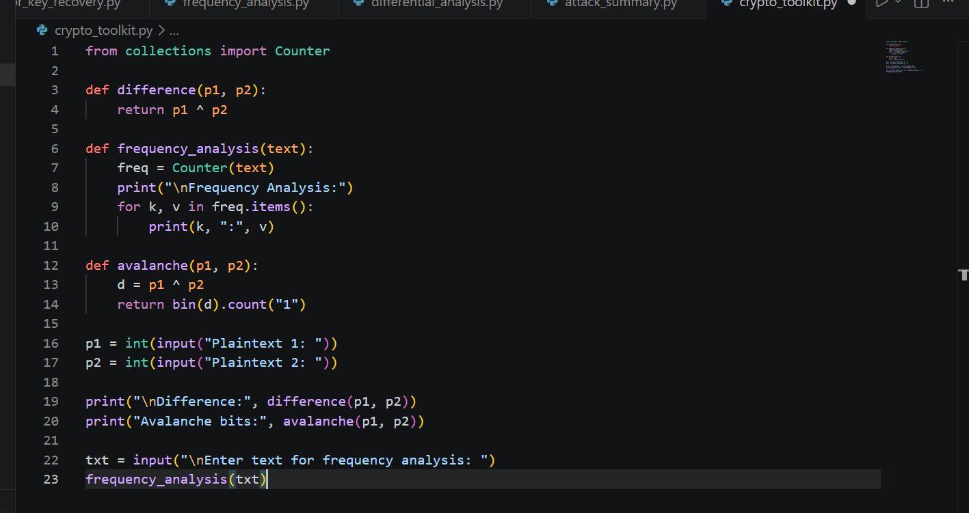
OUTPUT:
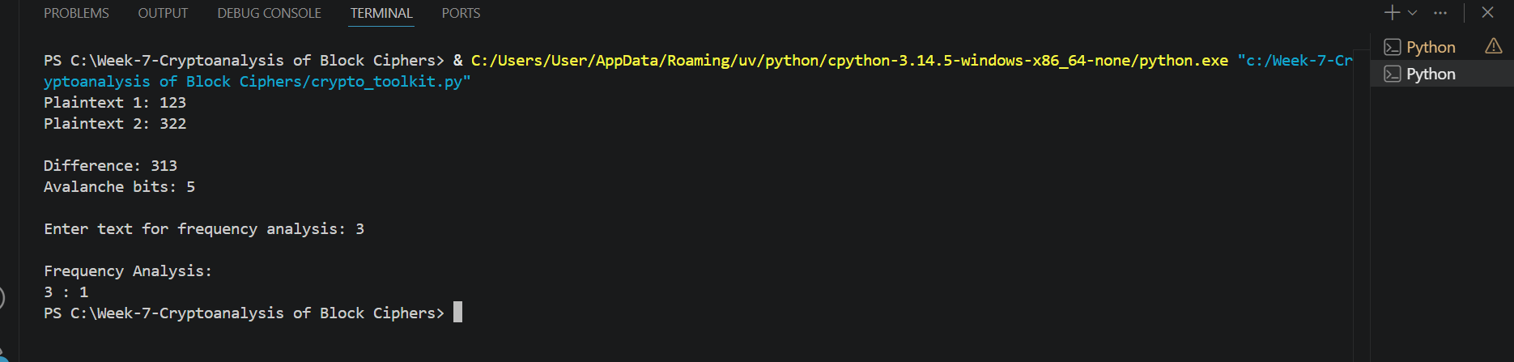

CHALLENGE TASK

Fig 1: Block Cipher Security Analyzer
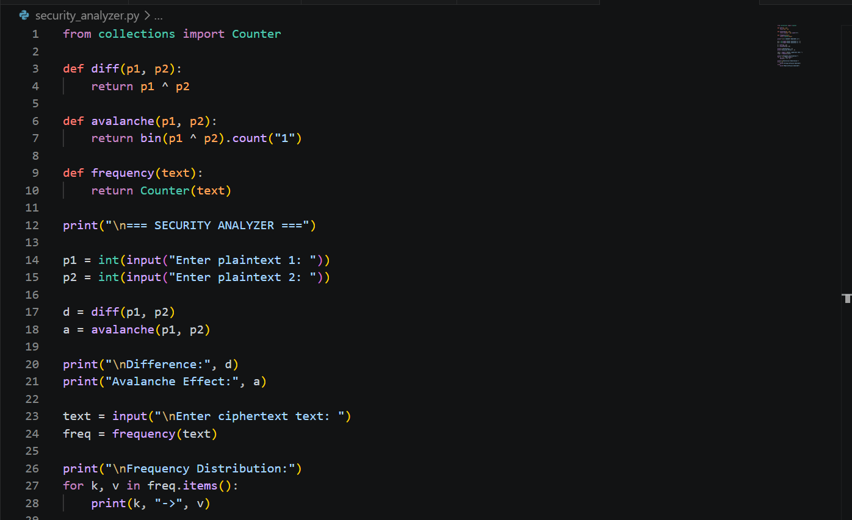
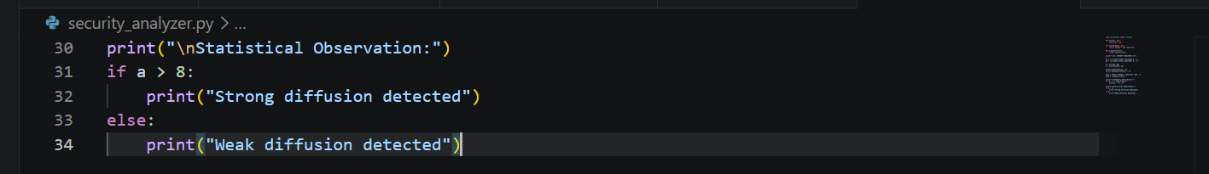
OUTPUT
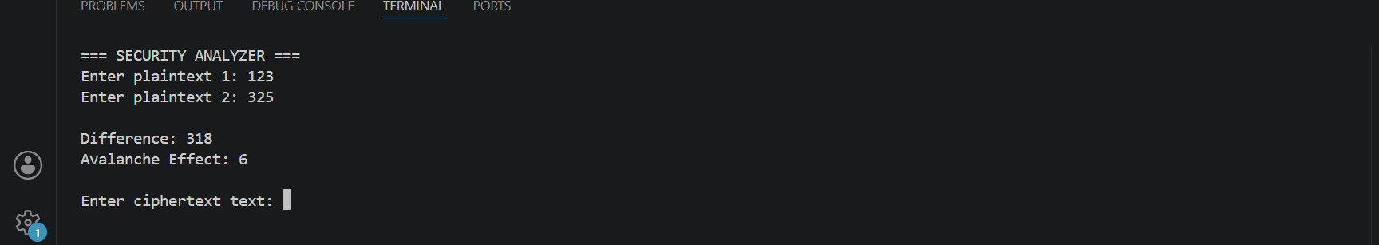

WEEK-7 REFLECTION
The cryptanalysis activities provided insight into how attackers analyze encrypted information. By performing known plaintext, frequency, and differential analysis, I learned how weaknesses in cipher design can be exploited. The exercises emphasized the need for robust encryption algorithms that can withstand analytical attacks.

